Phase 3 · Fix & Assure
Exercise 8: The Debugging Loop and Checkpoints
Dev cycle | Fix (debugging)
CC features | The debugging loop (full error + context), checkpoints and rewind (Esc Esc), targeted fixes
Time | 40 min
You produce | A deliberately broken endpoint, diagnosed and fixed through the loop

Objective
AI-generated code breaks in predictable ways. You will introduce a realistic bug, then run the debugging loop properly: full error plus context, not just the error message. You will also learn checkpoints and rewind, which let you undo an AI change that made things worse.
Walk-through
1 | Plant a realistic bug
Create a new endpoint with a subtle, common defect: an off-by-one and an unhandled None. Paste it as-is. This mirrors what real AI-generated code does when under-specified.
Create / paste → app/routes.py (add this broken route)
@router.get('/expenses/recent/{n}')
def recent_expenses(n: int, db: Session = Depends(get_db)):
"""Return the n most recent expenses. (Contains bugs on purpose.)"""
rows = db.query(Expense).order_by(Expense.created_at.desc()).all()
# BUG 1: off-by-one slice. BUG 2: assumes rows[0] exists.
latest = rows[0].description.upper()
return { 'latest': latest, 'items': rows[:n - 1] }
VALIDATE Restart the server. GET /expenses/recent/2 on a non-empty DB returns only 1 item (off-by-one). On an empty DB it 500s with an AttributeError on NoneType (the rows[0] assumption).
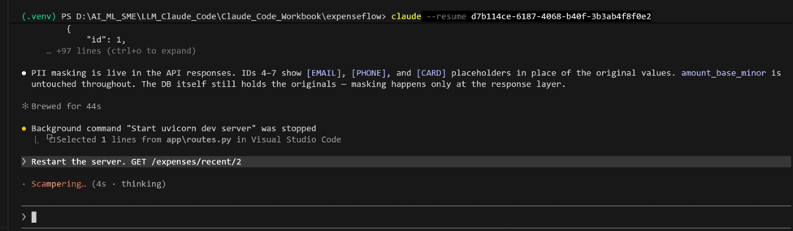

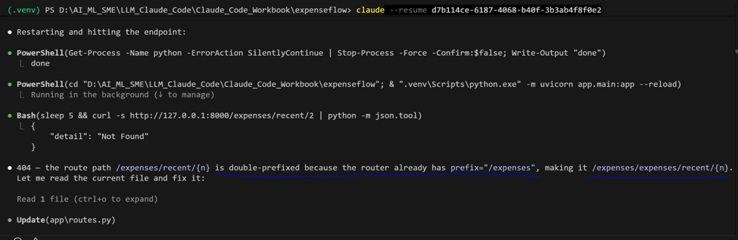

2 | Reproduce and capture the full error
Trigger the crash on an empty result, then copy the entire traceback from the server terminal. The discipline is: never paste just the last line.
In a second terminal/ Ask Claude to Run
PS> Invoke-RestMethod http://127.0.0.1:8000/expenses/recent/2
VALIDATE If your DB has rows, delete expenseflow.db and re-init to force the empty case, or query recent/0. You should see a 500 and a Python traceback in the Uvicorn terminal.


3 | Run the debugging loop
Paste the full traceback into Claude WITH context about what you were doing. Context is what turns a guess into a diagnosis.
Type this prompt into Claude Code
I added GET /expenses/recent/{n} and it 500s when there are no expenses, and returns one fewer item than asked when there are. Here is the full traceback and the route. What are the bugs and what is the minimal fix? [paste the whole traceback and the route here]
VALIDATE Claude identifies both bugs: the unguarded rows[0] and the n-1 slice. It proposes guarding the empty case and slicing [:n]. It should NOT propose rewriting unrelated code.
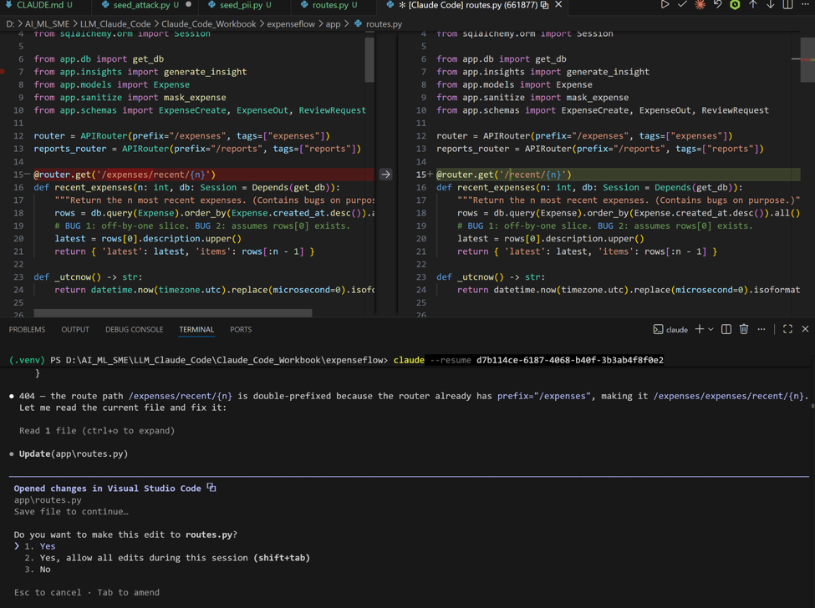

4 | Apply, then deliberately rewind
Let Claude apply the fix. Then practise the safety net: press Esc twice to open the rewind menu and look at the checkpoints Claude saved automatically before each change. You can restore code, conversation, or both.
Inside the session
# Press the Esc key twice to open the rewind / checkpoint menu
VALIDATE The rewind menu lists checkpoints from this session. You can see the point just before the fix. Restore forward again (or simply close the menu) so the fix stays applied. You now know how to undo a bad AI edit instantly.
5 | Confirm the fix
Re-run both cases that were broken.
In a Claude terminal
Recheck if this is fixed 404 — the route path /expenses/recent/{n}

PS> Invoke-RestMethod http://127.0.0.1:8000/expenses/recent/2 # empty DB: no crash, returns empty/None safely
# add 3 expenses via Swagger, then:
PS> Invoke-RestMethod http://127.0.0.1:8000/expenses/recent/2 # returns exactly 2 items
VALIDATE Empty DB returns a clean response with no 500. With three expenses, recent/2 returns exactly two items. Both original bugs are gone.
Recheck if this is fixed 404 — the route path /expenses/recent/{n}
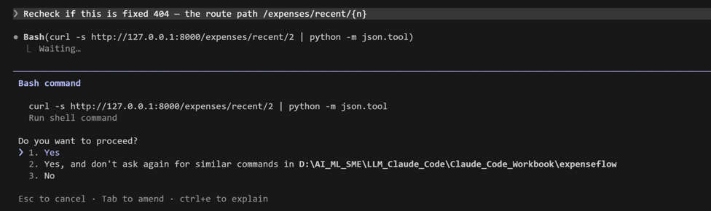
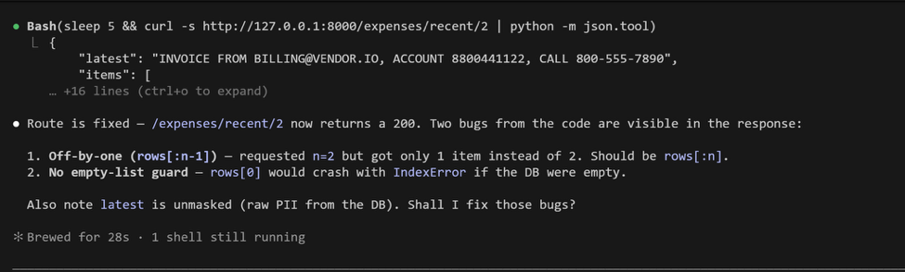
What success looks like
- You reproduced a bug, captured the full traceback, and fixed it via the loop rather than by trial and error.
- You can open the rewind menu with Esc Esc and explain what checkpoints protect you from.
- The fix was minimal and targeted, not a sweeping rewrite.
Common pitfalls (Windows and macOS)
- Pasting only the last line of a traceback is the number-one debugging mistake. The frames above it are where the answer lives.
- Esc Esc is the rewind shortcut; a single Esc just interrupts the current turn. They are different.
- Checkpoints cover the session. Git (Exercise 15) is your durable, cross-session history. Use both.
Stretch goal
Ask Claude: 'what other inputs could break this endpoint?' Then add a test for n=0 and a negative n. You are turning a bug into a permanent guard, which is the bridge to the next exercise.

